Auto-Generation of a GUID (*Globally Unique Identifier*) to be used as a UID in Semarchy

# Use case

When creating a new record in an entity, a 36-character GUID should automatically be generated and used as the UID for that record.

#### GUID example:

386a3b7c-08a0-416a-be53-48fddb9556a5

# Pre-requisite to enable the use of GUIDs in Semarchy

The extension “uuid-ossp” should be created in the extensions schema in the Semarchy database. View the relevant Semarchy documentation [here](https://www.semarchy.com/doc/semarchy-xdm/xdm/2023.1/Install/database-configuration.html).

#### Example script to create the extension:

CREATE SCHEMA extensions;

GRANT USAGE ON SCHEMA extensions TO PUBLIC;

ALTER DEFAULT PRIVILEGES IN SCHEMA extensions GRANT EXECUTE ON FUNCTIONS TO PUBLIC;

ALTER DATABASE <postgresql_database_name> SET SEARCH_PATH TO "$user",public,extensions;

CREATE EXTENSION IF NOT EXISTS "uuid-ossp" with schema extensions;

CREATE EXTENSION IF NOT EXISTS "fuzzystrmatch" with schema extensions;

# Solution

1. Ensure that the extension “uuid-ossp” has been created in the database schema as above.
2. In the Application Builder, navigate to Database Functions in the left-hand navigation pane. Right-click **Database Functions** and click **Add Database Function.**

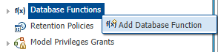

1. Enter the Database Function details, using “uuid_generate_v4” as the function name. Click **Finish**.

*Other UUID functions are available* [*here*](https://www.postgresql.org/docs/current/uuid-ossp.html)*.*

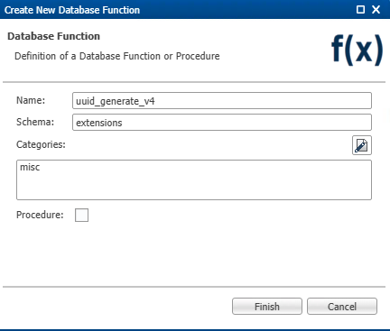

The function may now be called when generating UIDs.

1. In the model diagram, identify the entity that needs to have the primary key set as a GUID. Right-click the entity and click **Alter Entity** then click **Next**.

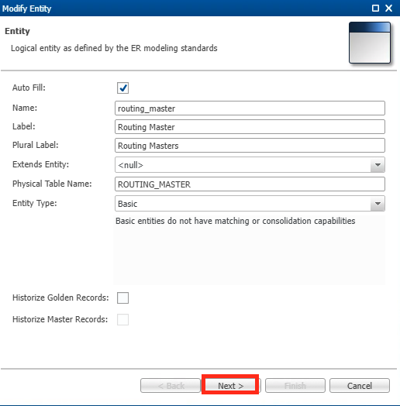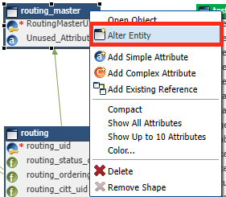

1. On the Primary Key Attribute screen, select the **SemQL** radio button, then click the **Modify Expression** icon.

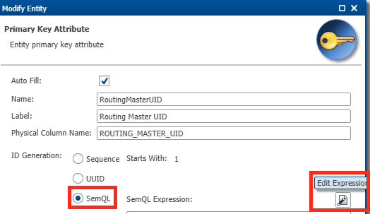

1. In the Functions section, expand the relevant category and locate the added extension. Double-click the extension, check that the SemQL Expression is updated and click **OK**.

1. Back on the Primary key Attribute screen, change **Type** to String and set **Length** to 36 (or whatever length is appropriate). Click **Finish**.

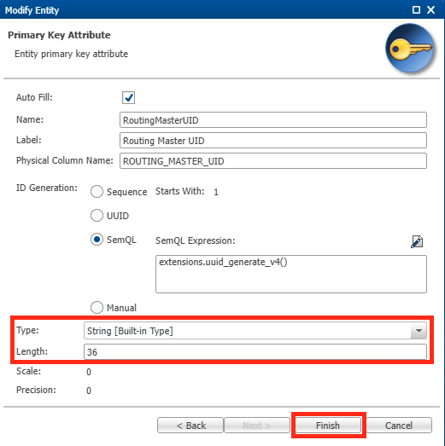

1. Save, validate, and deploy the model. Refresh the application.

# Example

1. In the application, open the entity and create a new record:

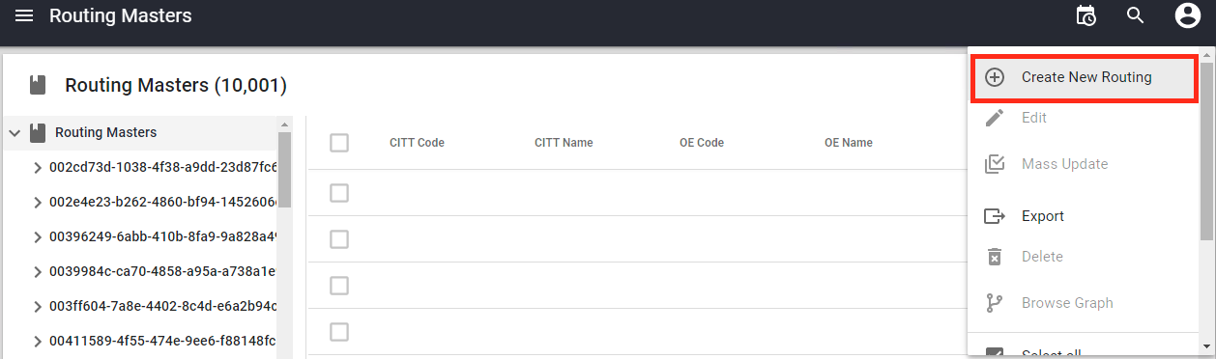

1. The GUID is created and set as the primary key for this new record:



**<< END >>**